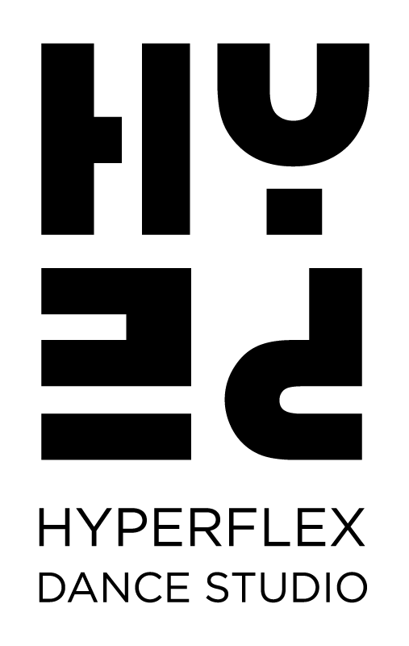

2023-2024 Attire Requirements
Ballet:
Junior Grades Ballet; Jr 1-3: will all require light pink ballet tights, leather full sole ballet slippers and the CAPEZIO Short sleeved bodysuit, in LIGHT BLUE.

Grade 1 to Grade 6 Ballet: will require; light pink ballet tights, full sole leather ballet slippers, and a tank or spaghetti strapped bodysuit in BURGANDY/MAROON.

Intermediate and Advanced Ballet Classes: will require; light pink ballet tights, and a tank or spaghetti strapped bodysuit in BLACK.
Intermediate Foundation/Intermediate: require leather, full sole ballet slippers
Advanced: Canvas split sole slippers, or a leather, full sole shoe.

Please choose simple, proper ballet bodysuits, not fashion suits.

*Proper ballet hair and buns are also a must for ALL ballet classes, requiring hairnets and pins.

Boys: Please wear black ballet tights, a white or black short sleeved dance shirt, and black ballet slippers

Jazz:
Junior 1-6 classes: beige slip on, Bloch Jazz bootie.
Pre-Inter- TBA
Inter/Advanced Jazz and up: Capezio Pirouette spinners in Nude.

Boys: Black Slip-on Bootie

Please wear proper, tight fitting dancer wear for all jazz classes

Tap:
Grade 1 -2 Tap- Beige, ‘Tap on’ tap shoe
Grade 3 Tap- BEIGE, lace up Oxford HARD SOLE shoe
Grade 4-Advanced- BLACK, lace up Oxford HARD SOLE-PLEASE
Adult Tap- Oxford lace up Tap shoes
Boys: Black tie up oxfords
Proper Dance wear is required for all tap classes.

***Please note:
If your previous shoes fit, please do not worry about new shoes right
away. Old ones will suffice for the first little while.
We ask you to have them by Christmas break.
Grade 3- Please note NEW SHOES
____________________________________________

Lyrical:
Junior 5 Lyrical Beige slip-on Bloch jazz bootie. Boys- black slip on

Pre-Int and Up- Capezio Pirouette spinners in Nude for both girls and boys
Please wear proper, tight fitting dancer wear.

Hip Hop:
All Classes: Indoor, clean runners are required for all hip-hop classes.
We will inform you of competition shoes at a later date.
Please wear comfortable, moveable clothing and have hair tied back.

Acro:
All Classes: Please make sure you are in tight dance shorts or leggings
and bodysuit, half or tank top. Please have bare feet.

Hair must be French braided and tied up, or in a tight low bun.
Hair not tied back properly can be stepped on. Loose clothing is a
Hazard for spotting. It is extremely important to have no loose
clothing or hair. Dancers will not be allowed to participate due to safety
if not in proper hair and attire.

Aerial:
Aerial classes will require long sleeve tight fitting tops and/or bodysuits,
and leggings. Hair must be completely tied back. Dancer’s wear bare
feet.
There will be hand rosin provided during classes.

HYPETOTS Pre-School Classes:
Ballet/Tap: Beige CAPEZIO Tyette tap shoes, and leather ballet slippers.
Ballet/Creative Movement: Leather ballet slippers
Tights and bodysuit of any color.

Skirts and tutus are encouraged for both programs
Please have hair tied back.

Boys: Black tap shoe, and/or black ballet slipper. Please wear moveable, comfortable clothing. Ballet shorts or pants are recommended but not required.

_______________________________________________________

